Automated Acoustic Calibration for Experimental Rigs
Technical report

Status | Validated — Ready for Deployment
Date | 6/6/2026
Sweep file | 256kMeasSweep_0_to_20000_-12_dBFS_48k_Float_mono.wav
Reference mic | miniDSP UMIK-1 (cal file: 7101790_90deg.txt)
Mic to be calibrated | Rig camera mic
Speaker to be calibrated | USB PnP Sound Device
Target SPL | 78 dBSPL (400 Hz – 10 kHz)
Daily tolerance | ±1 dB stereo 78 dBSPL (up to 2 volume corrections per cycle; all rounds logged to DB)

Introduction
This report presents a Python-based automated audio calibration application designed to replace manual calibration procedures and external tools such as Room EQ Wizard (REW) in acoustic test rigs, while also enabling calibration of the rig speaker and microphone using a calibrated reference microphone with calibration files and REW. The system provides precise and repeatable calibration of measurement setups, ensuring a consistent and accurately controlled sound field across all rigs, with a standardised daily output level of 78 dBSPL. It replicates the core measurement chain used in REW and has been validated against REW measurements to confirm its accuracy and reliability.
Purpose of calibration
Behavioural neuroscience experiments depend on the stimulus being the same every time. If the speakers on one rig play a tone louder than the speakers on another, or if a single rig drifts week to week, or speaker output ununiformly across different frequencies, then the sound level becomes a hidden variable influencing animal behaviour and downstream analysis. As a result, observed differences may reflect variations in stimulus intensity rather than true experimental effects.
The established way to measure a loudspeaker's response is REW (Room EQ Wizard) with calibrated miniDSP UMIK-1. REW is trusted, but it is a manual, GUI-driven tool: an operator drives it by hand, one rig at a time, and reads results off a screen. That does not scale to a fleet of rigs and cannot run unattended on a daily schedule. This project keeps REW's rigour while removing its limitations. This project preserves the measurement rigour of REW while removing its practical limitations. It achieves this in three key ways:
- Becomes scriptable and verifiable. The REW measurement chain is reimplemented in Python and checked against REW's own exported curves, so the automated pipeline is provably equivalent to the trusted reference, rather than an approximation.
- Enable low-cost fixed rig mic to function as a calibrated one. A one-time calibration procedure against a reference UMIK-1 microphone to report absolute dBSPL.
- Closes the loop, daily and unattended. Each rig measures itself, adjusts its own output to hit the 78 dBSPL target, confirms left/right balance, and logs the result to a database for drift tracking and auditability.
Prerequisites
Hardware
- The rig's stereo speakers and its fixed “rig” microphone (the camera mic in its permanent location).
- For the one-time mic calibration only: a calibrated UMIK-1 reference microphone, placed in the inner box in front of the pokewall, midway between the two speakers.
Reference files
- The UMIK-1 calibration file (e.g. 7101790_90deg.txt), which carries the mic's frequency response and its sensitivity factor.
- The standard REW measurement sweep: a 48 kHz mono exponential sine sweep, from 0 to 20k Hz frequency range (256kMeasSweep_0_to_20000_-12_dBFS_48k_Float_mono.wav）
- The per-rig mic-calibration file produced after mic calibration (created once, then reused every day).
Software environment
- Python with numpy, scipy, sounddevice and soundfile; PortAudio installed for live audio I/O.
- Ubuntu with PipeWire/PulseAudio — system volume is read and set through wpctl (preferred) or pactl.
- A results database and server endpoint for logging and uploading each daily calibration.

System Architecture and Workflow
The workflow has three stages, performed at different times. The operational workflow steps through validating the algorithm against reference REW curves, performing a baseline installation calibration, and shifting to automated operational maintenance.; The table below summarises what each stage produces and how often it runs:
Stage | Script | When | What it produces
A. Verification and validation | 1. Mimic_REW_sweep.py  2. Mimic_REW_analysis.py | Once, on the bench | Proof that the Python measurement matches REW (overlay plots + combined CSV).
B. Rig mic calibration | 3. calibrate_mic.py | Once per rig, at install | A per-rig file that converts the fixed mic's raw reading into absolute dBSPL and calibration file in txt.
C. Speaker calibration | 4. calibrate_speaker.py  With helper functions sound_calibration_utility.py | Automatically, daily | Speakers driven to 78 dBSPL ±1 dB, L/R balance verified, result logged to the database., also produce parquet and png files
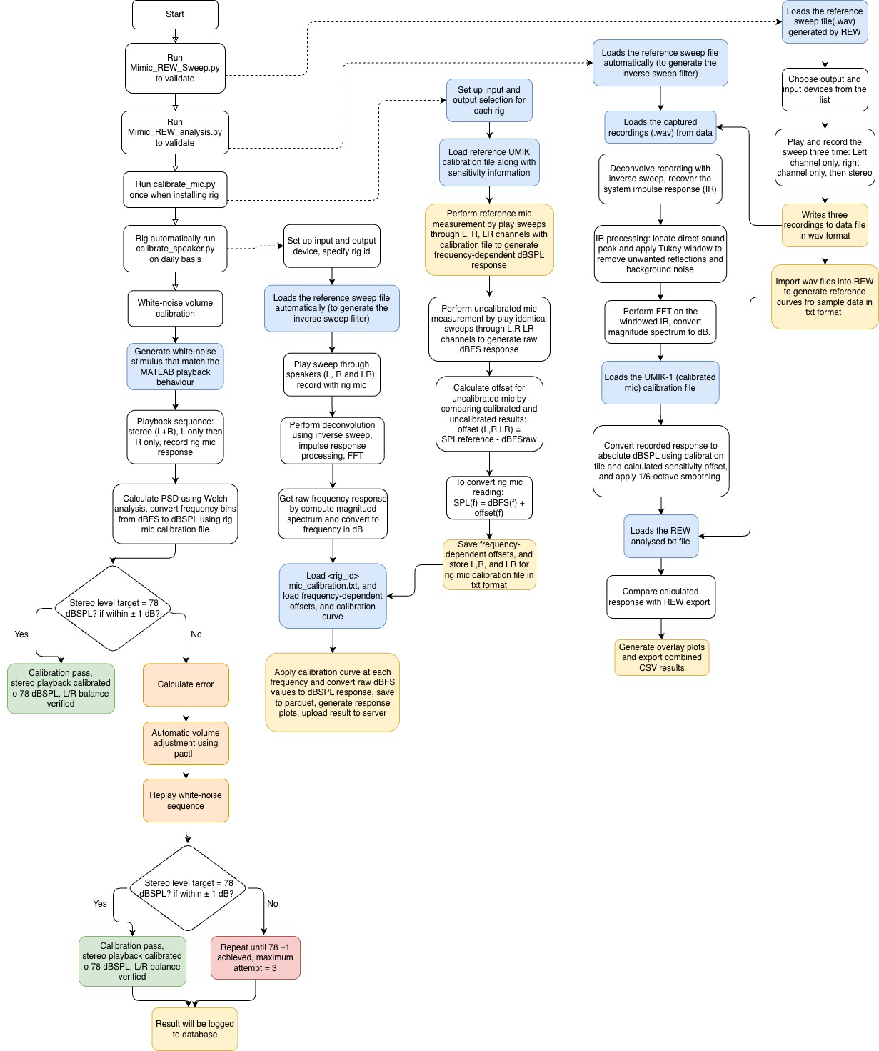
The accompanying flowchart shows the full procedure step by step:
Acoustic Measurement Methodology

All acoustic measurements in the pipeline follow a five-stage processing chain implemented in Mimic_REW_analysis.py and sound_calibration_utility.py; ESS → IR → FFT → log-grid → smoothing, mirroring the methodology used in professional room acoustics tools such as REW.
ESS (Exponential Sine Sweep):
An exponential sweep (0–20 kHz, REW-generated reference file) is played through the speaker to excite the full audio band with equal energy per octave. The microphone records the system’s response to this known stimulus.
IR (Impulse Response):
The recorded signal is deconvolved with an analytically generated inverse sweep to isolate the system’s impulse response. A Tukey window gate is applied (125 ms pre-peak, 500 ms post-peak) to reduce reflections while preserving low-frequency content.
FFT (Frequency Response):
The gated impulse response is transformed into the frequency domain using an FFT to obtain the system’s magnitude response. When available, UMIK-1 calibration and sensitivity offsets are applied to convert dBFS values to absolute dBSPL.
Log-grid (Logarithmic Resampling):
The linear FFT output is interpolated onto a 2,000-point logarithmic frequency scale (10 Hz–20 kHz) to match perceptual frequency spacing and ensure comparability with REW outputs.
Smoothing (1/6-octave):
A 1/6-octave fractional smoothing is applied to reduce narrow-band fluctuations caused by room effects, producing stable curves suitable for calibration and comparison.
Dual Validation Methodology
A dual-validation methodology was developed to verify that the custom Python implementation reproduces the frequency-response measurements obtained from Room EQ Wizard (REW). The validation consisted of two independent processing paths using identical measurement data, excitation signals, calibration information, and analysis parameters. The resulting frequency-response curves were compared to assess agreement between the two approaches.

REW Reference Measurement
The reference measurement was obtained using REW’s native acoustic measurement workflow. An exponential sine sweep (ESS) was generated in REW and exported as a WAV file. This sweep served as the common excitation signal for all subsequent measurements.
The sweep was reproduced through the audio system and recorded using a calibrated UMIK-1 measurement microphone. Three measurements were acquired corresponding to the left channel, right channel, and stereo playback configurations. The recorded signals were stored as WAV files for subsequent analysis.
The recorded waveforms were then imported back into REW together with the original sweep signal. REW automatically generated the inverse sweep filter from the stimulus signal and performed its standard ESS-based acoustic measurement procedure, including deconvolution and frequency-response estimation. The resulting sound pressure level (SPL) responses were exported as text files containing frequency-response data from 10 Hz to 20 kHz. These exported responses served as the reference datasets for validation.

Independent Python Analysis
The same recorded waveforms and original REW sweep file were analysed using the custom script mimic_REW_analysis.py. The objective was to reproduce REW’s frequency-response calculation using an independently implemented signal-processing pipeline designed for deployment within the automated calibration workflow.
The analysis began by loading the original exponential sweep signal and generating an analytical inverse sweep filter. Each recorded waveform was subsequently deconvolved with the inverse filter to recover the system impulse response (IR).
To replicate REW’s processing behaviour, the direct-sound peak of the impulse response was automatically detected and a Tukey window was applied around the peak. The window parameters matched those used in REW, consisting of 125 ms preceding the direct arrival, 500 ms following the direct arrival, and a Tukey shape parameter of α = 0.25. This operation reduced the influence of late reflections and background noise while preserving the direct acoustic response.
The windowed impulse response was transformed into the frequency domain using the Fast Fourier Transform (FFT). The resulting magnitude spectrum was converted to logarithmic amplitude values expressed in digital full-scale decibels (dBFS).
Absolute sound pressure level calibration was then applied using the UMIK-1 calibration file. The calibration header was parsed to extract the microphone sensitivity parameters, including the sensitivity factor (Sens_Factor) and analogue gain correction (AGain). A broadband sensitivity offset was calculated according to:
$$\text{Sensitivity Offset}=102-\text{Sens_Factor}+\text{Again}$$
The calculated offset was added directly to the FFT magnitude spectrum, converting the response from relative digital units (dBFS) to absolute sound pressure level units (dBSPL).
Following calibration, the spectrum was resampled onto a logarithmically spaced frequency grid and processed using 1/6-octave smoothing to match the REW analysis settings. The resulting frequency-response data were then exported for comparison.
Comparison Procedure
The frequency-response curves generated by the Python pipeline were compared with the corresponding REW reference responses obtained from the same measurements. Overlay plots were generated to enable visual assessment of agreement between the two processing methods, and numerical comparison data were exported in CSV format for further analysis.
The comparison demonstrated close agreement between the Python-generated responses and the REW reference curves across the measured frequency range. The observed deviations remained within the expected resolution introduced by the applied smoothing, indicating that the custom Python implementation successfully reproduces the frequency-response analysis performed by REW.

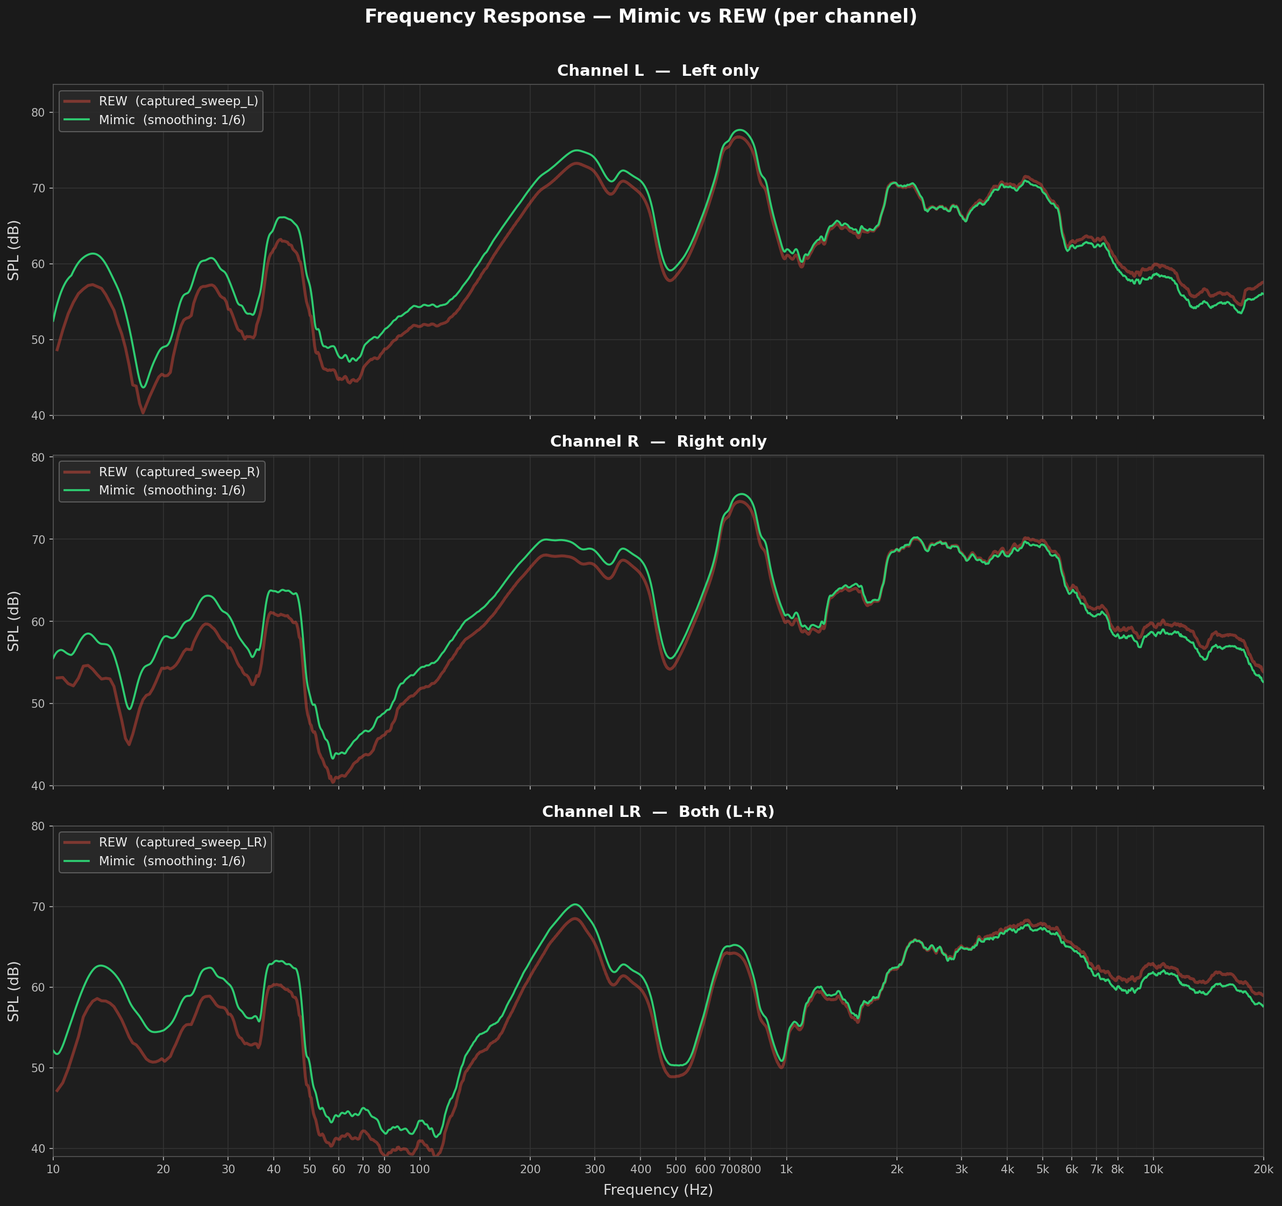
Figure 1. The validation plot shows the Mimic curve (green) tracking the REW reference (red) across all three channels from 20 Hz to 20 kHz. The curves are visually indistinguishable in the 200 Hz - 10 kHz band where the calibration is used. Below 80 Hz, minor differences arise from room-mode temporal smear and the IR gate, consistent with the known limits of gated measurements at low frequencies. These low-frequency deviations are acceptable and expected.

One-time Rig Mic Calibration
Once the Python pipeline has been validated, calibrate_mic.py is executed once per rig during initial installation. This procedure characterises the built-in camera microphone relative to a calibrated UMIK-1 reference microphone and stores the resulting correction data in a rig-specific calibration file.

Sweep-based calibration procedure
At the beginning of the calibration process, the operator selected the audio output device connected to the loudspeakers, the calibrated UMIK-1 microphone, and the uncalibrated rig microphone. The rig microphone calibration procedure was performed to determine the frequency-dependent correction required to convert measurements from the rig microphone into absolute sound pressure level (SPL) values. A calibrated UMIK-1 measurement microphone was used as the acoustic reference standard throughout the procedure.
Two successive sweep measurements are performed under an identical, fixed acoustic configuration. In the first pass, the standard logarithmic sine sweep covering the audible frequency range was reproduced through the loudspeakers sequentially through the left, right, and stereo channels and recorded using the calibrated UMIK-1 microphone. The recorded signal was processed using the frequency-response correction data and sensitivity factor contained within the UMIK calibration file. This compensation removed the influence of the microphone’s inherent frequency-response deviations and converted the measured signal into an estimate of the true acoustic sound pressure level within the enclosure. The resulting measurement produced a frequency-dependent reference SPL spectrum, $SPL_{ref}\left(f\right)$, representing the physical sound pressure level at each frequency.
The same sine sweep was subsequently reproduced and recorded using the uncalibrated rig microphone, under identical conditions. In this case, no calibration corrections were applied during processing. The resulting spectrum therefore represented the raw digital output of the rig microphone expressed in decibels relative to full scale, $dBFS_{test}\left(f\right)$. This measurement captured the combined effects of the rig microphone’s sensitivity and frequency response characteristics.
Before calculating the calibration offsets, the software verified that the calibrated and uncalibrated measurements shared an identical frequency grid. This ensured that corresponding frequency bins could be directly compared. For each frequency and for each playback configuration (left speaker, right speaker, and both speakers combined), a frequency-dependent calibration offset was calculated as:
$$\text{offset}\left(f\right)={\text{SPL}}_{\text{ref}}\left(f\right)-{\text{dBFS}}_{\text{raw}}\left(f\right)$$
As a result, the calculated offset incorporates the rig microphone sensitivity, its frequency-response deviations, the sweep playback level, and the UMIK-1 calibration reference.
For validation, the mean offset within the 250 Hz–4 kHz band is computed for each channel. Cross-channel consistency is assessed by taking the spread between the maximum and minimum band-mean offsets. This spread was found to remain within the 3 dB consistency threshold, indicating stable calibration across left, right, and stereo channels. When applied, the calibrated rig microphone reproduces SPL values derived from the UMIK-1 within the expected frequency smoothing resolution.
Broadband white-noise calibration
In addition to the frequency-dependent sweep calibration, a broadband correction factor is derived using a white-noise stimulus. For each of the left, right, and stereo channels, an identical white-noise burst generated using the same routine as in the speaker calibration stage to ensure consistency of playback conditions, which is presented and recorded separately by the UMIK-1 and the rig microphone.
The broadband offset is computed by energy integration over the measurement band:
$$WN_{offset}=UMIK_{dBSPL}-dBFS_{raw}$$
This yields a single scalar correction per channel (WN_offset_L, WN_offset_R, WN_offset_LR). These values complement the frequency-dependent calibration by providing a band-integrated reference suited to broadband experimental stimuli.

Calibration file structure
The calibration file contains a header with the rig identifier, calibration timestamp, reference UMIK-1 calibration file, selected smoothing parameters, and the three broadband white-noise offsets.
Each subsequent row encodes the frequency-dependent correction applied independently per channel:
$$SPL\left(f\right)={\text{dBFS}}_{\text{raw}}\left(f\right)+offset\left(f\right)$$
This representation captures the combined effects of sweep level, UMIK-1 sensitivity, and the frequency response of the rig microphone. Each calibration run is written to a timestamped file, ensuring that new calibrations do not overwrite previous results.
Limitation: position dependency of calibration
The calibration is only valid for the specific physical configuration in which it was performed. It captures the combined effects of the rig microphone position, UMIK-1 reference microphone position, loudspeaker placement, and enclosure acoustics.
Any change to this setup invalidates the calibration. Therefore, calibrate_mic.py must be re-run whenever the system geometry or hardware configuration is altered, including changes to the microphone, speakers, reference microphone position, or enclosure structure.
After any modification, the full measurement workflow must be repeated with all components returned to their defined reference positions before recalibration. This is a procedural requirement; the script does not automatically detect configuration changes.
Daily Speaker Calibration
Once a rig microphone calibration file exists, calibrate_speaker.py performs the routine acoustic calibration of the rig. The script is launched once per rig and, on startup, loads the calibration data, prompts the user a single time to select the output (speaker) and input (rig microphone) devices, and immediately executes an initial full calibration cycle. The process then remains resident and automatically repeats the same cycle daily at 02:00 without further operator input. Any failure during an automated run is caught and logged, allowing the process to continue running so that a single failed cycle does not interrupt long-term operation.
Firstly, the operator manually selects the rig microphone calibration file from the calibration directory, with the most recent file listed first by default. From the selected file, both the frequency-dependent offsets and the broadband white-noise offsets (WN_offset_L, WN_offset_R, WN_offset_LR) are read from the header. The numeric rig identifier used for database logging is derived from the system hostname.
Each calibration cycle consists of two stages: an archival sweep measurement followed by a closed-loop white-noise level calibration.
Stage 1: Sweep measurement and archiving
The standard exponential sweep is played through the speakers across the left, right, and stereo channels and recorded with the rig microphone. Each recording is processed through the validated measurement chain: inverse-filter deconvolution, impulse-response windowing, FFT, log-grid resampling, and 1/6-octave smoothing, to yield a raw response in dBFS. The rig microphone's per-frequency offsets are then interpolated onto the measurement grid and applied to convert the response to absolute sound-pressure level:
$$SPL\left(f\right)={\text{dBFS}}_{\text{raw}}\left(f\right)+offset\left(f\right)$$
The calibrated left, right, and stereo responses are written to a timestamped Parquet file, synchronised to the central server via rsync, and rendered as a response plot (shown below). This stage is archival in nature, producing a daily per-rig record of the full frequency response for fleet-wide drift monitoring. The sweep-derived level is reported for reference only and is not used for adjustment; level control is handled exclusively by the white-noise calibration stage.
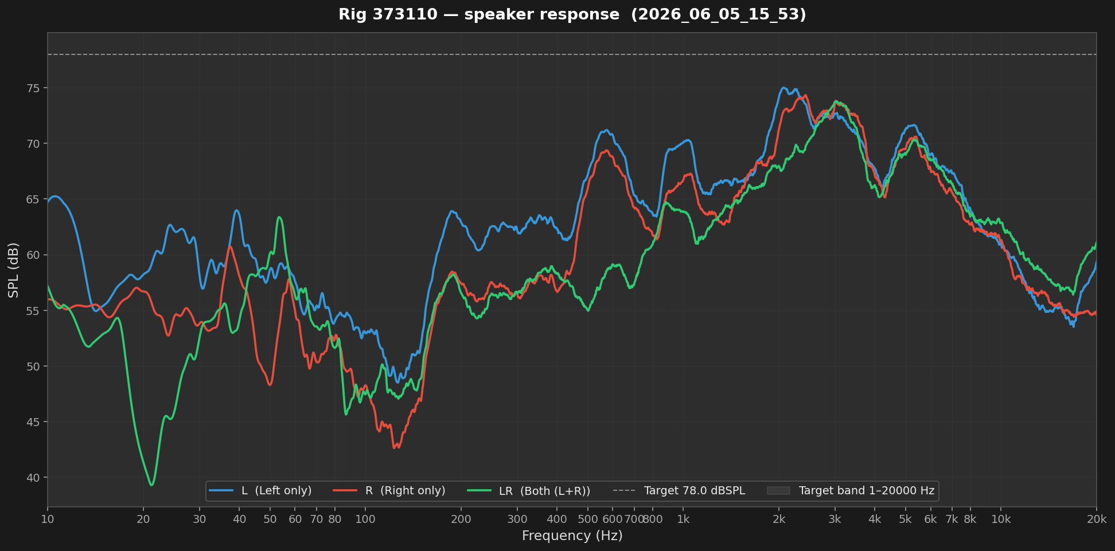
Figure 2: Calibrated speaker frequency response for rig 373110 (2026-06-05). Left (blue), right (red), and stereo (green, L+R) responses obtained by sweeping each channel, deconvolving to recover the system response, and applying the rig-mic per-frequency offsets to convert to absolute SPL (SPL(f) = dBFS_raw(f) + offset(f), 1/6-octave smoothed). Dashed line: 78 dBSPL reference target; shaded region: 1 Hz–20 kHz band. This sweep is archival, documenting response shape for drift monitoring; absolute level is set separately by the white-noise stage.
Stage 2: White-noise level measurement
As the experimental stimuli consist of broadband white noise generated in MATLAB, level calibration is performed using a matching white-noise stimulus. The noise is generated as uniform random samples scaled to an amplitude ratio of 0.5, reproducing the ±0.5 peak amplitude of the MATLAB reference signal. This amplitude was determined empirically through iterative tuning, where the playback level was adjusted in small increments and the resulting SPL was compared against a MATLAB reference using the REW SPL meter under identical acoustic conditions.
The left and right channels are driven by two independent noise draws rather than a shared signal. Consequently, the two loudspeakers radiate uncorrelated signals whose powers add incoherently at the microphone, resulting in the stereo (L+R) measurement being approximately 3 dB higher than a single channel. This configuration reflects true two-channel playback rather than a coherent mono signal.
For each measurement, the stimulus is played as a fixed-duration burst, with an initial 1 s warm-up segment discarded to avoid transient effects. The recorded signal is analysed using a Welch power spectral density estimate (scaling="density"). Each spectral bin is converted to an RMS-equivalent level expressed in dBFS (referenced to a full-scale sine wave, RMS = 1/√2 ≡ 0 dBFS) and then converted to dB SPL using the calibration offsets. The total broadband level is obtained by energy summation across the analysis band (1 Hz–20 kHz):
$$L_{band}=10\log_{10}\left(\sum{{10}^{SPL_{bin}/10}}\right)$$
For the dBFS-to-dBSPL conversion, the script uses the broadband white-noise offset determined by calibrate_mic.py under the same Welch-based convention. This is preferred over sweep-derived offsets, which are based on a deconvolution reference and are not directly compatible with broadband noise.
A fixed empirical correction term, WN_SPL_TRIM_DB (3.96 dB), is applied to account for a constant offset between the internal calibration convention and an external sound level meter reference. The final channel level is therefore given by:
$$SPL_{channel}=dBFS_{raw, Welch}+WN_{offset, channel}+WN_SPL_TRIM_DB$$
Each round measures the stereo, left, and right channels in turn.
Closed-loop level adjustment and pass criterion
Stereo white noise is played through both speakers simultaneously, and the resulting sound pressure level (SPL) is compared to the target of 78 dB SPL. The measurement is considered a pass if it falls within ±1 dB of this target; otherwise, it is recorded as a fail. The left-minus-right channel difference is also computed and stored for diagnostic purposes, but it does not affect the pass/fail decision. Large L/R differences therefore indicate channel imbalance or per-speaker gain issues.
If the stereo level is off target (78dB SPL), the system output volume is adjusted via PulseAudio (pactl). Given that PulseAudio’s percentage scale is approximately cubic in decibels, the required adjustment is computed as:
$$new_{percent}=current_{percent}⋅{10}^{\left(target-measured\right)/60}$$
After adjustment, the white-noise measurement is repeated. This adjust-and-remeasure loop is limited to a maximum of two iterations; if convergence is not achieved within this bound, the closest attained level is retained.
Each calibration round, regardless of pass or fail, is logged to the sound_calibration database. Recorded fields include the rig identifier, stereo pass/fail status, signed L/R level difference, and the system volume at the time of measurement. This provides a continuous, auditable record of calibration stability across rigs and allows non-converging systems to be flagged for maintenance.
Environment setup and safety checks
In the beginning of mic calibration, the system was prompt to force all microphone input gains to exactly 100%, this not only unmutes them to prevent inaccurate recording, also prevent any skewed and inconsistent recording between each recording, due to accidentally volume setup. this make sure there is a equal volume to begin with.
For both calibration python file, users must select the input and output hardware devices manually from a list, to make sure the speaker and microphone are correctly selected and not using a random one from the system to avoid waste of time.

End-To-End Validation
A final end-to-end check confirmed that the calibrated levels reported by the Python pipeline agree with an independent REW sound-level meter, and that the same levels are reproduced by the MATLAB experimental playback. With calibrate_speaker.py running, REW's SPL meter was monitored on the rig computer while the script played its white-noise stimulus, and the meter reading was recorded for the stereo, left, and right channels. Immediately afterwards, the equivalent white-noise stimulus was played from MATLAB through the same channels and speakers, and the REW SPL meter readings were again recorded.
Across three trials, the script's computed levels matched the REW meter readings to within approximately 0.3 dB on every channel, and the MATLAB playback reproduced the same levels to within the meter's reading precision. This provides direct, independent confirmation of two things: the Python calibration reports absolute SPL accurately against a reference meter, and the level it targets transfers faithfully to the MATLAB stimulus that drives the actual experiments. The stereo (L+R) level sits at the 78 dBSPL target across all trials, with the expected lower per-channel levels consistent with incoherent stereo addition.
Trial No. | Speaker Channel | Python [dB SPL] | Actual REW SPL meter reading [dB SPL] | MATLAB + REW reading [dB SPL] | Check
1. | L+R (stereo) | 77.79 | 77.9 | 77.9 | ✅
 | L | 75.18 | 75.4 | 75.4 | ✅
 | R | 74.43 | 74.7 | 74.7 | ✅
2. | L+R (stereo) | 77.78 | 78.0 | 77.8 | ✅
 | L | 75.34 | 75.3 | 75.4 | ✅
 | R | 74.37 | 74.6 | 74.7 | ✅
3. | L+R (stereo) | 77.78 | 78.0 | 78.0 | ✅
 | L | 75.24 | 75.5 | 75.5 | ✅
 | R | 74.47 | 74.5 | 74.5 | ✅
Table 1. End-to-end level validation for rig 373110 across three trials. For each trial, the level computed by calibrate_speaker.py (Python [dB SPL]) is compared against an independent REW SPL-meter reading taken during the script's white-noise playback (Actual REW SPL meter reading [dB SPL]) and against the REW reading obtained when the equivalent white-noise stimulus is played from MATLAB (MATLAB + REW reading [dB SPL]). All channels agree to within ~ 0.3 dB, confirming both meter-accurate calibration and parity between the calibration target and the MATLAB experimental playback.
Conclusion
This work delivers an automated acoustic calibration system that provides measured, controlled, and auditable stimulus levels across the experimental rigs. Validation demonstrated that the Python measurement pipeline reproduces REW results, that per-rig microphone calibration enables accurate absolute SPL measurement using fixed microphones, and that daily closed-loop speaker calibration maintains the 78 dB SPL target automatically. End-to-end testing showed agreement with an independent sound level meter to within approximately 0.3 dB and confirmed that the calibrated levels are faithfully reproduced by the MATLAB experimental playback system. By replacing manual calibration with an automated, self-correcting, and fully logged workflow, the system improves reproducibility, reduces inter-rig variability, and establishes a consistent acoustic standard across the facility.

